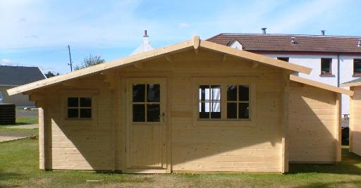

Chalet T24 6.5 m x 4.0 m
Roof projection: Front 1.00 m
Back 0.20 m
Side 0.20 m

Price:

45mm: £ 3,242

Consists of:

Walls: sturdy 45 mm double tongue and groove wall boarding from northern fir.
Flooring: 20 mm tongue and groove floor boards on the impregnated fundament frame.
Roof: 20 mm tongue and groove roof boards on the roof beams.
Overhanging canapy – 100 cm. Roof coating is not included in the price.
Door: 1 unit 90/195
1 unit 63/195.
The doors could be fully glazed, glass on top half or without glass.
Windows: 2 tilt‘n‘turn units 120/91
2 tilt‘n‘turn units 70/65
1 tilt‘n‘turn unit 70/88

